NAME: ____________________________________ **Peppered Moth Simulation**

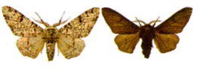

**Objective:**

Simulate changes in moth population due to pollution and predation and observe how species can change over time.

## Introduction:

Charles Darwin accumulated a tremendous collection of facts to support the theory of evolution by natural selection. One of his difficulties in demonstrating the theory, however, was the lack of an example of evolution over a short period of time, which could be observed as it was taking place in nature. Although Darwin was unaware of it, remarkable examples of evolution, which might have helped to persuade people of his theory, were in the countryside of his native England. One such example is the evolution of the peppered moth Biston betularia.

The economic changes known as the industrial revolution began in the middle of the eighteenth century. Since then, tons of soot have been deposited on the country side around industrial areas. The soot discoloured and generally darkened the surfaces of trees and rocks. In 1848, a dark-coloured moth was first recorded. Today, in some areas, 90% or more of the-peppered moths are dark in colour. More than 70 species of moth in England have undergone a change from light to dark. Similar observations have been made in other industrial nations, including the United States.

**Go to the following website**: <https://serpmedia.org/scigen/l4.2b.html>

1. Slide the circle on the timeline at the bottom of the screen forward in time and describe the changes that occurred.

_______________________________________________________________

_______________________________________________________________

1. Click **NEXT** and look at the moths on the screen. Even though they are of the same species they have different colors. These differences are known as v_____________________.
2. Click **NEXT** and follow the directions. There are **3** different years being examined over the next few slides. Record the year, and then which moth you think would be easier to see and therefore eaten first?

|  |  |
| --- | --- |
| **YEAR** | **Moth that would be easier to see..**  Light Colored or Dark Colored |
|  |  |
|  |  |
|  |  |

1. Click **NEXT** and follow directions on the screen. Compare the population of light colored moths to dark colored moths. What was the **cause of these changes** over the time periods shown?

________________________________________________________________

________________________________________________________________

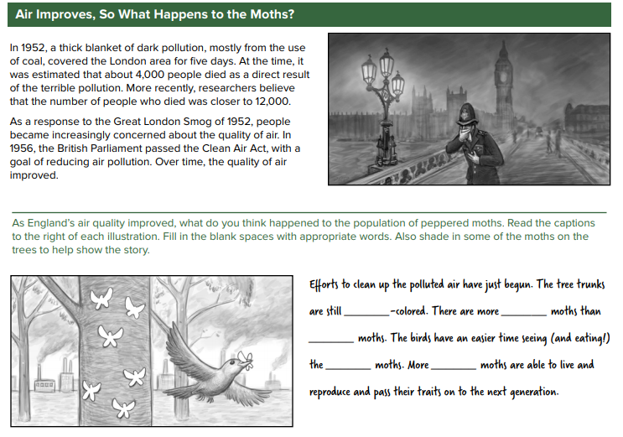

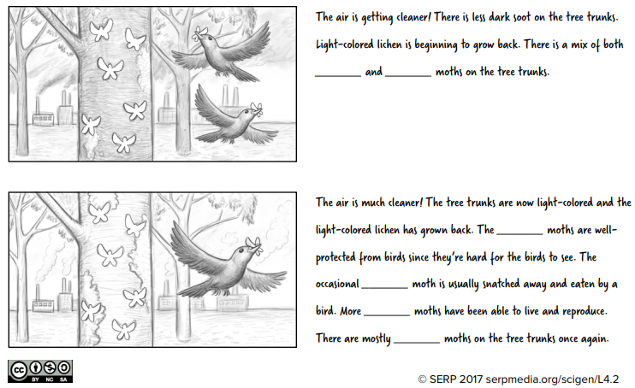

**USE THE FOLLOWING WEBSITE TO COMPLETE THE SIMULATION:**

<https://askabiologist.asu.edu/activities/peppered-moth>

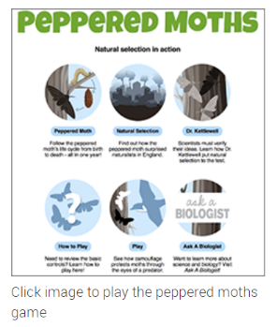

1. Scroll down and click on:

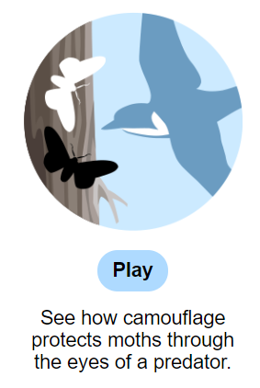

1. Next, click the **PLAY** button below this image:
2. You will play the role of the bird in both the dark and the light forest. Try to behave as a bird would behave, choosing the moths that are the most obvious. At the end of each simulation, record the **percent of moths captured** in the table below.



## Final Analysis

22. Explain how the color of the moths increases or decreases their chances of survival.

23. Explain the concept of "natural selection" using your moths as an example.

24. What would happen if there were no predators in the forest? Would the colors of the moths change over time? Defend your answer?